

**Project Report**

**On**

**Design a full-fledged network for an organization with multiple subnets**

Course Code: CSE-405

Course Title: Computer Networks

Semester: Fall 2018

Section: 3

**Submitted To**

Dr. Anisur Rahman

Assistant Professor

Department of Computer Science and Engineering

East West University

**Submitted By**

Md. Shariful Islam

ID: 2014-2-60-111

**Submission Date: 17-12-2018**

**Project Statement:**

We are given a mission on creating an entire version of the complex community by means of coming across the interconnectivity of the systems and subnetworks, on the way to mirror the INTERNATIONAL APEX University’s shape and facilities supplied. On this assignment, we are able to configure DHCP with a purpose to routinely assign IPv4 addresses to any host from the assigned IPv4 address block of our design. Also the HTTP protocol with advocated packet tracer. (Cisco Packet Tracer)

**Overview:**

In our assignment’s community model, we've used Cisco Packet Tracer for the implementation. There are major service, one is Dynamic Host Configuration Protocol (DHCP) and another is Hypertext transfer Protocol (HTTP).

Dynamic Host Configuration Protocol (DHCP) is a network protocol that permits a server to robotically assign an IP to a computer from a described variety of numbers configured for a given network. DHCP permits to move a pc, which include a pc, among diverse locations without reconfiguring the TCP/IP placing. For example, if a college member had a laptop which he desired to take from his office to a networked school room to give in magnificence, DHCP will allow the laptop to hook to the community in both locations without reconfiguring the pc. Or if a pupil has a computer she desires to use to get right of entry to the network in numerous places round campus, DHCP will take care of the TCP/IP configuration.

In our undertaking’s network model, there's one server (DHCP) that is related to a transfer. That transfer is connected to many other switches that refers to library server, ICS labs, faculty server, classroom server, staff server, software program and Database lab. Each server is a sub-community. Within the DHCP server there are few numbers of ports wherein we've got used handiest one port to attach a switch that creates a sub-network. From that transfer port we've got linked many other switches. Consequently, the number of ports have increased exponentially. In future which can be multiplied creating subnets from them. These are the stressed community connections. Alongside of those, we've used 2 Wi-Fi community routers in order that you possibly can join there pill or cellular cellphone and use internet service.

HTTP is designed to permit intermediate community factors to improve or allow communications among clients and servers. Excessive-site visitor’s websites regularly gain from internet cache servers that deliver content on behalf of upstream servers to enhance reaction time. Web browsers cache previously accessed web sources and reuse them whilst viable to reduce network traffic. HTTP proxy servers at private community limitations can facilitate communique for customers without a globally routable deal with, by using relaying messages with external servers.

The usage of these two configuration, we have attempted to create that entire version of complex community that reflects the INTERNATIONAL APEX University’s shape and centers.

**Used components:**

1. DHCP Server
2. Switches
3. Routers
4. Wireless Routers
5. PC
6. Laptop
7. Printer
8. Media Server
9. Mobile phone
10. Tablet PC
11. Connectors

**Network Diagram:**

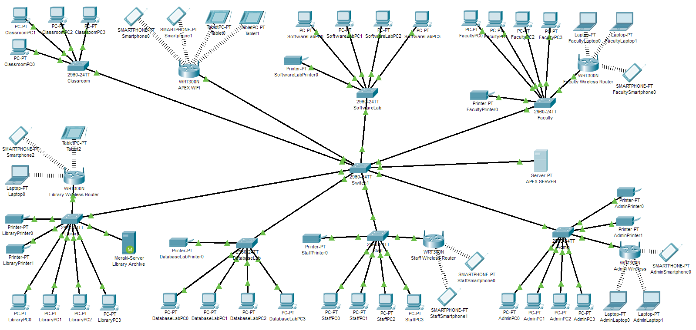

Figure-1: Network Model created in Cisco Packet Tracer

**PC:** Here PC is used in different places like Classrooms, Library, Employee PC etc.

**Switch:** Switch is used to connect all things together.

**DHCP Server:** From this server all IP is providing dynamically.

**DNS Server:** This server will convert the web server address to IP address.

**Router:** Router is using to develop wireless connection.

**Laptop and Smartphone:** Users can use internet by using Laptop and Smartphones by Router.

**Classroom:** There are some PCs in the classroom and this PCs are connected with switch and gets IP from the DHCP server and webserver can be accessed from any PC of the classroom.

**Lab:** There are some PCs in the purpose of lab and this is also connected with a switch and this is directly connected to the main switch.

**Employee:** In our network there are PC for employee which is also connected similarly as the classroom and lab.

**Library:** All the pc from the library is also connected with the main switch with another switch. Administrative like others, this PCs for administrative system is designed with switch to connect the main switch to get all privileges from the network.

**Router:** Router is used to provide service by WIFI. Wirelessly devices get access of the web server through this router.

**DHCP server:** It is connected by main Switch and it is providing IP for PC. PCs are having IP dynamically. A starting IP is given which provides IPs to other devices.

**DNS server:** DNS server is used to convert address to IP address. In the DNS server into the services DNS service is turned on. We set the name of the web server and the IP address of the web server and saved it into the DNS server. So, when any device tries to get access of the web server using the web server name, DNS server translates it into IP and shows the web server.

**Web Server:** Web server is used to provide the webpage to the user. Here, we have turned on the http service and we have imported necessary files that makes the web server visible to other devices.

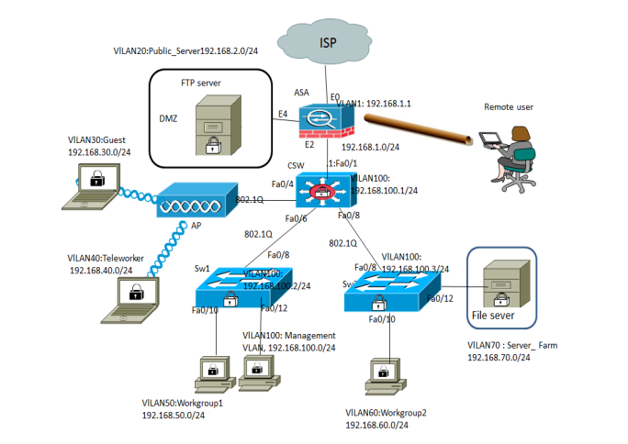

**Figure: LAN Network**

**Code:**

DHCP Setup CLI:

Continue with configuration dialog? [yes/no]: no

Press RETURN to get started!

Router> enable

Router# config t

Router(config)# interface fa 0/0

Router(config-if)# ip address 192.168.13.254 255.255.255.0

Router(config-if)# no shut

Router(config-if)# exit

Router(config)# ip dhcp pool serverPool

Router(dhcp-config)# network 192.168.13.0 255.255.255.0

Router(dhcp-config)# default-router 192.168.13.100

Router(dhcp-config)# exit

**Conclusion:**

In this project, we have carried out DHCP and HTTP in Cisco Packet Tracer, where in the configuration of DHCP is routinely assign IPv4 address to any other host from the assigned IPv4 address block of our design. Also our net-server generates website which reflects the business enterprise profile.